Jenkins Task-02

Jenkins
Jenkins is an open-source automation server used to build, test, and deploy applications through Continuous Integration and Continuous Delivery (CI/CD) pipelines.
Jenkins Master
The Jenkins Master manages job scheduling, configuration, user access, and distributes build tasks to connected slave (agent) machines.
Jenkins Slave (Agent)
A Jenkins Slave is a machine connected to the Jenkins Master that executes build jobs, helping distribute workloads and improve performance.
GitHub Webhooks
Webhooks are event-based triggers that automatically notify Jenkins when changes (such as code commits) occur in a GitHub repository.
Poll SCM
Poll SCM is a Jenkins trigger that periodically checks the source code repository and triggers a build only when changes are detected.
Build Periodically
Build Periodically is a Jenkins scheduling feature that triggers jobs at fixed time intervals using cron expressions.
Thin Backup Plugin
Thin Backup is a Jenkins plugin used to back up Jenkins global configuration and job-specific data for recovery and migration purposes.
---------------------------------------------------------------------------------------------------------

Overall Tasks Title
Jenkins CI/CD Setup, Automation, Backup, and Disaster Recovery Implementation
Overall Tasks Objective
To design and implement a complete Jenkins Continuous Integration setup by configuring slave nodes, enabling automated job triggers, implementing multiple backup strategies, and restoring Jenkins on a new server to ensure high availability, automation, and disaster recovery readiness.
Overall Tasks Prerequisites
- Jenkins installed and running on a master EC2 instance
- Two additional EC2 instances available for Jenkins slave nodes
- Java installed on master and slave machines
- SSH connectivity between Jenkins master and slave nodes
- GitHub repository for Jenkins jobs
- Jenkins plugins installed (Git, SSH Agent, ThinBackup)
- Administrative access to Jenkins
- Linux shell access with sudo/root privileges
- Backup storage space available on the server

Task Title
Configure 2 slave machines in Jenkins master.
Objective
To configure two Jenkins slave (agent) machines and connect them to a Jenkins master server using SSH-based authentication on AWS EC2 instances.
Prerequisites
- AWS account
- 3 EC2 instances:
  - 1 Jenkins Master
  - 2 Jenkins Slaves (slave-01, slave-02)
- Amazon Linux 2 / Amazon Linux 2023 AMI
- Java installed on all instances
- Jenkins installed and running on Master
- Port 22 open for SSH and 8080 open for Jenkins in Security Groups
Architecture Overview
- Jenkins Master manages jobs
- Jenkins Slaves execute jobs
- Communication between Master and Slaves happens via SSH using key-based authentication
Step 1: Launch EC2 Instances
- Launch three EC2 instances (t3. micro is sufficient for practice).
- Name them:
  - Master
  - slave-01
  - slave-02
3.Attach Security Group with:
  - SSH (22) – Anywhere or your IP
  - Custom TCP (8080) – Anywhere (for Jenkins UI)
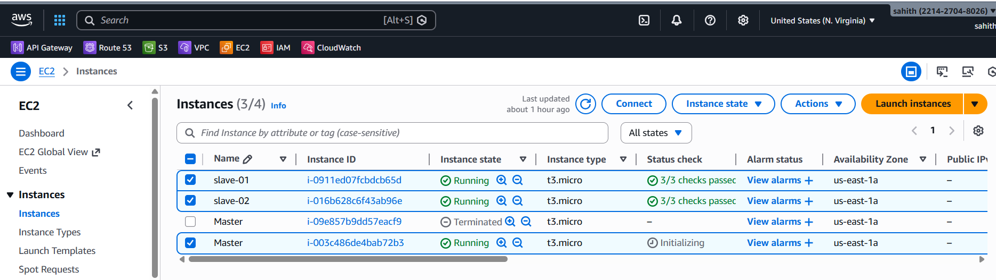
Step 2: Install Java on All Instances
- Login to Master, slave-01, and slave-02.
- Install Java using the below command:
sudo yum install java-17-amazon-corretto -y
- Verify Java installation using:
java -version
Step 3: Install Jenkins on Master
- Login to Master instance.
- Install Jenkins using the following commands:
sudo wget -O /etc/yum.repos.d/jenkins.repo https://pkg.jenkins.io/redhat-stable/jenkins.repo
sudo rpm --import https://pkg.jenkins.io/redhat-stable/jenkins.io-2023.key
sudo yum install jenkins -y
- Start and enable Jenkins service:
sudo systemctl start jenkins
sudo systemctl enable jenkins
- Open Jenkins UI in browser using:
http://<Master-Public-IP>:8080
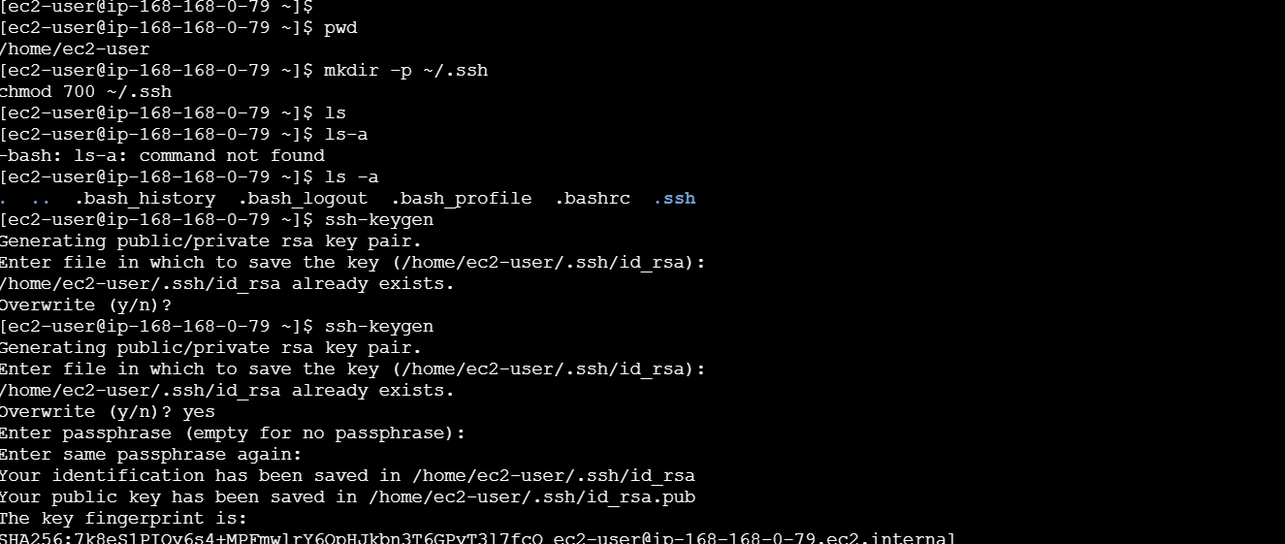
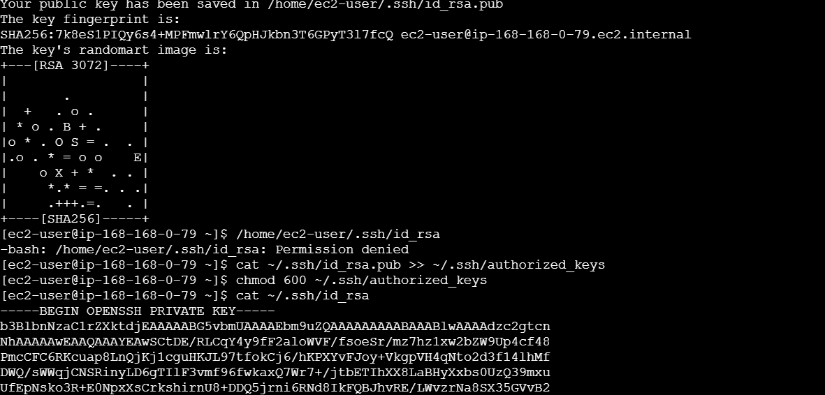
Step 4: Generate SSH Keys on Slave Machines
- Login to slave-01 instance.
- Create .ssh directory:
mkdir -p ~/.ssh
chmod 700 ~/.ssh
- Generate SSH key pair:
ssh-keygen
- Press Enter for all prompts (do not set passphrase).
- Repeat the same steps on slave-02.
Step 5: Configure Authorized Keys on Slaves
- On each slave machine, run:
cat ~/.ssh/id_rsa.pub >> ~/.ssh/authorized_keys
chmod 600 ~/.ssh/authorized_keys
- Verify files exist using:
ls ~/.ssh
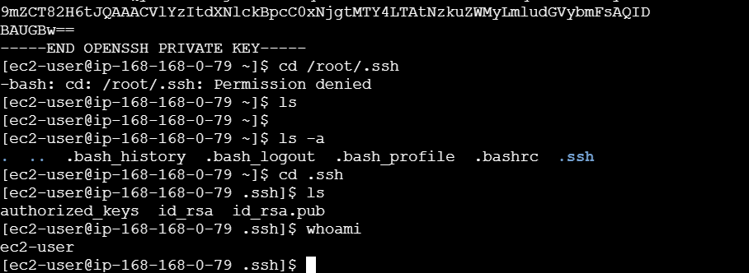
Step 6: Add SSH Credentials in Jenkins
- Open Jenkins dashboard.
- Go to Manage Jenkins → Credentials → System → Global credentials.
- Click on Add Credentials.
- Select Kind as “SSH Username with private key”.
- Enter username as ec2-user.
- Select “Enter directly” for private key.
- Copy the private key from slave machine using:
cat ~/.ssh/id_rsa
- Paste the private key into Jenkins.
- Set ID as slave-01.
- Save the credentials.
- Repeat the same process for slave-02 with ID slave-02.
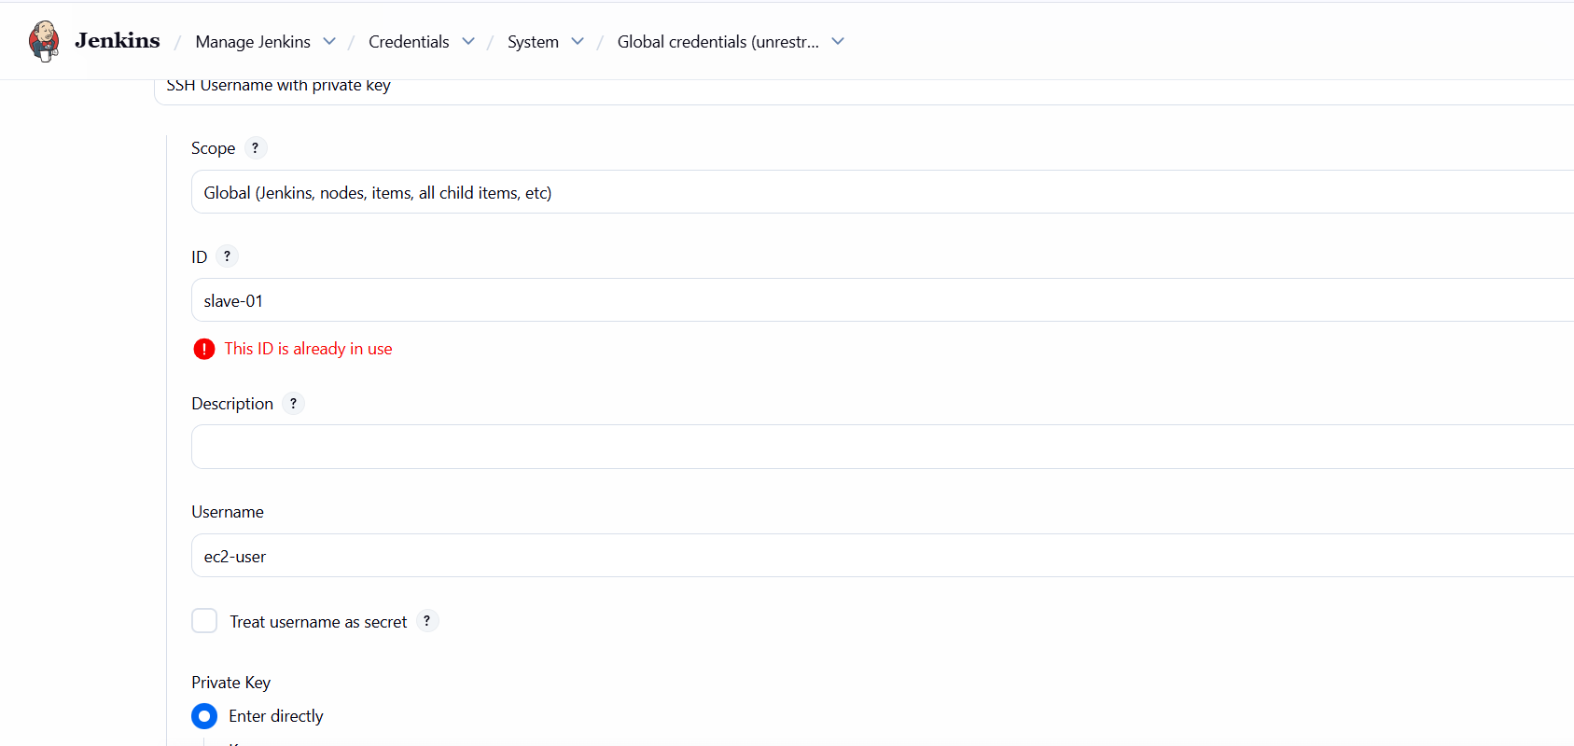
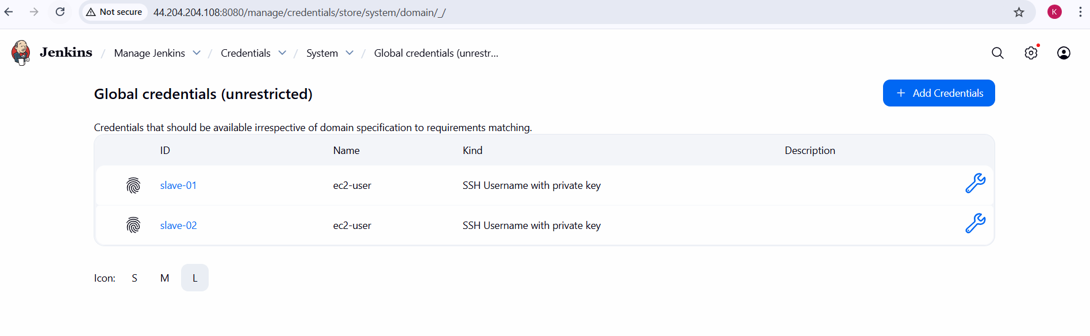
Step 7: Configure Jenkins Slave Nodes
- Go to Manage Jenkins → Nodes → New Node.
- Enter node name as slave-01.
- Select Permanent Agent and click OK.
- Configure the following:
  - Remote root directory: /home/ec2-user
  - Labels: slave-01
  - Usage: Use this node as much as possible
  - Launch method: Launch agents via SSH
  - Host: Private IP of slave-01
  - Credentials: slave-01
- Save the configuration.
- Repeat the same steps for slave-02.
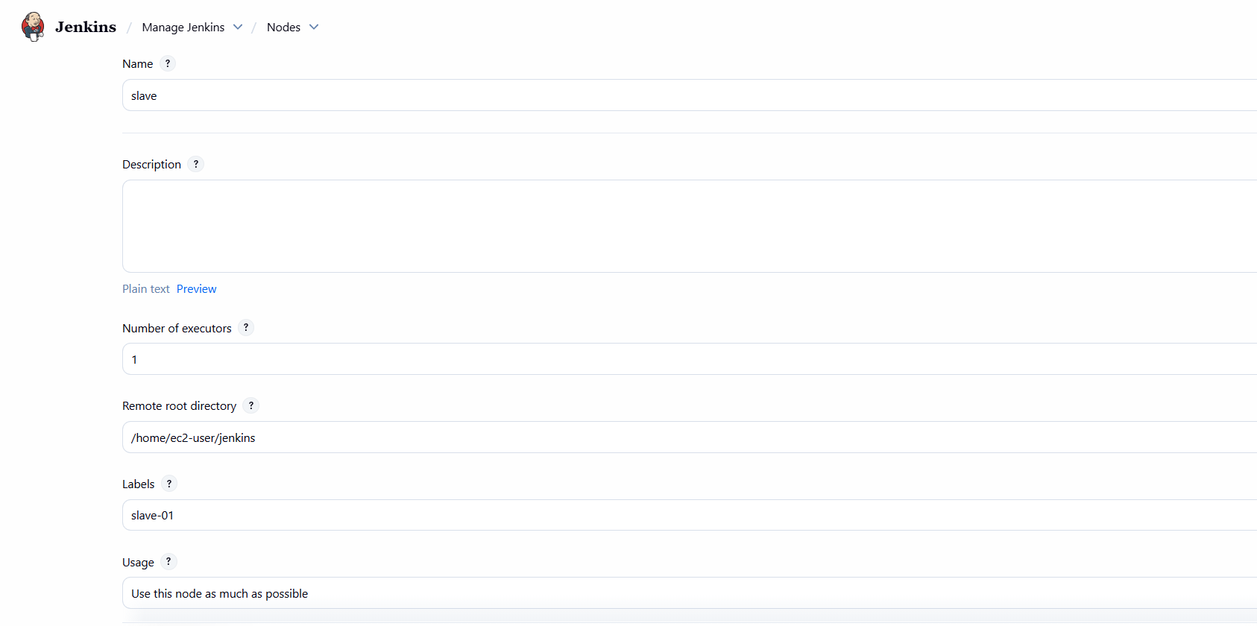
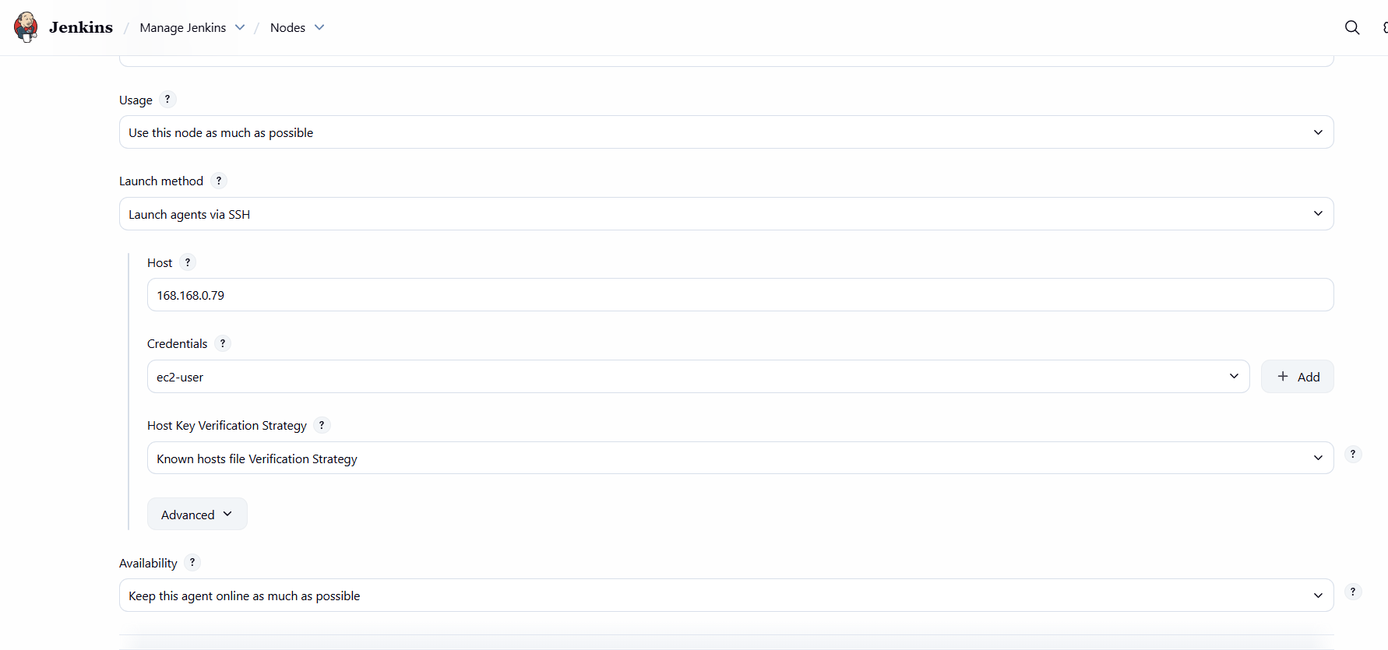
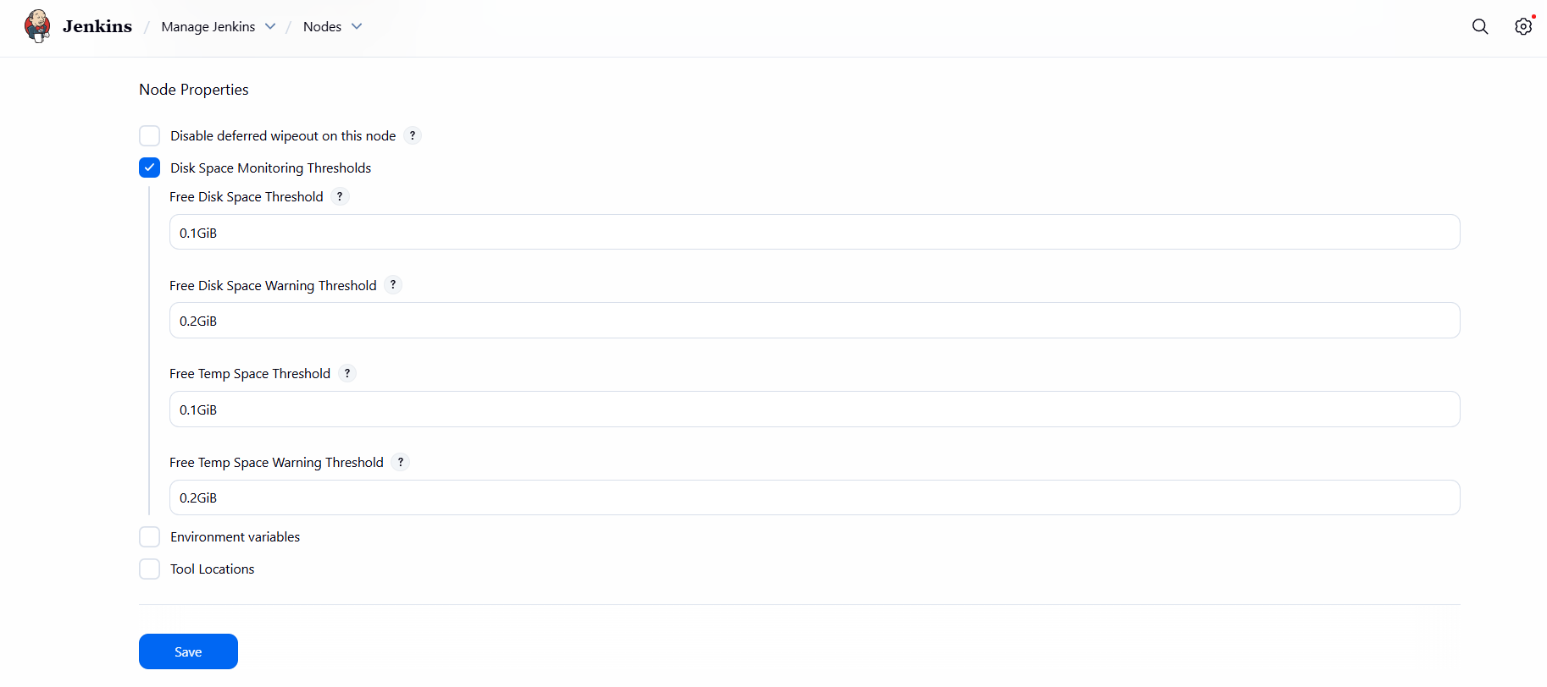
Step 8: Verify Slave Connection
- Go to Manage Jenkins → Nodes.
- Check the status of slave-01 and slave-02.
- Both nodes should appear Online.
- Executor status should show 1/1.
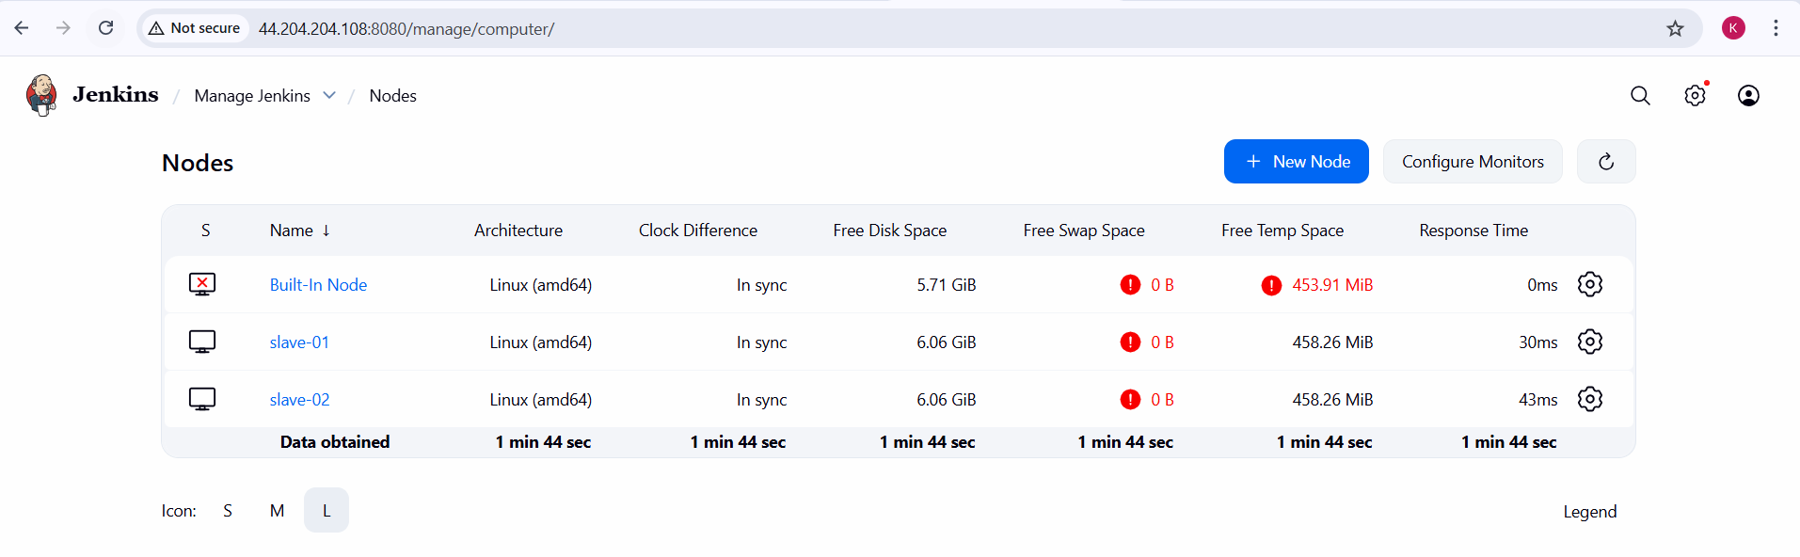
Error
- Server rejected the private key
- Authentication failed
Reason
- Incorrect private key
- Wrong username
- Permission issue on .ssh directory
Fix
chmod 700 ~/.ssh
chmod 600 ~/.ssh/authorized_keys
- Disk Space Warning
Disk space below threshold on /tmp
Reason
Low disk size in t3.micro instance
Fix
sudo rm -rf /tmp/*
Conclusion:
In this task, Jenkins master was successfully configured with two slave (agent) machines using SSH on AWS EC2 instances. SSH key-based authentication was implemented to allow secure communication between the master and slave nodes. Both slave nodes were added as permanent agents and verified to be online and ready to execute build jobs. This setup helps distribute build workloads efficiently, improves performance, and demonstrates a practical understanding of Jenkins distributed architecture in a real-time AWS environment.

Task Title
Configure Webhooks to Jenkins Job
Objective
To configure GitHub webhooks so that any code changes pushed to a GitHub repository automatically trigger a Jenkins job.
Prerequisites
• Jenkins server is up and running
• Jenkins job already created
• GitHub repository available
• Jenkins has Git and GitHub plugins installed
• Jenkins is accessible over public IP
• GitHub repository access available
Steps performed:
- Login to Jenkins
- Open Jenkins URL in browser
- Login with Jenkins credentials
- Create a New Jenkins Job
- Click on New Item
- Enter job name: WebhookTask
- Select Freestyle project
- Click OK
- Configure Source Code Management
- Go to Source Code Management section
- Select Git
- Enter Repository URL:
https://github.com/krishnav7090/Git-1.git
- Select credentials (GitHub credentials added earlier)
- In Branches to build, enter:
*/master

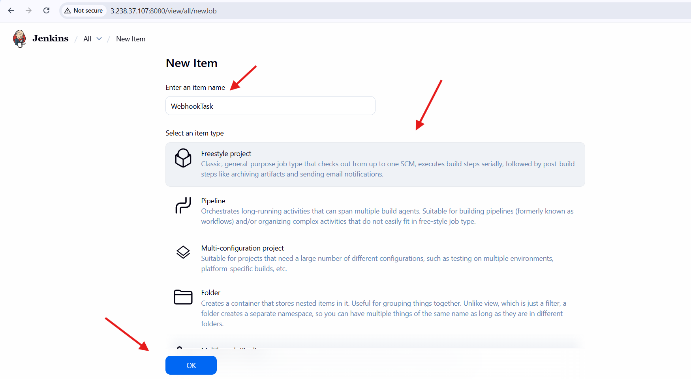
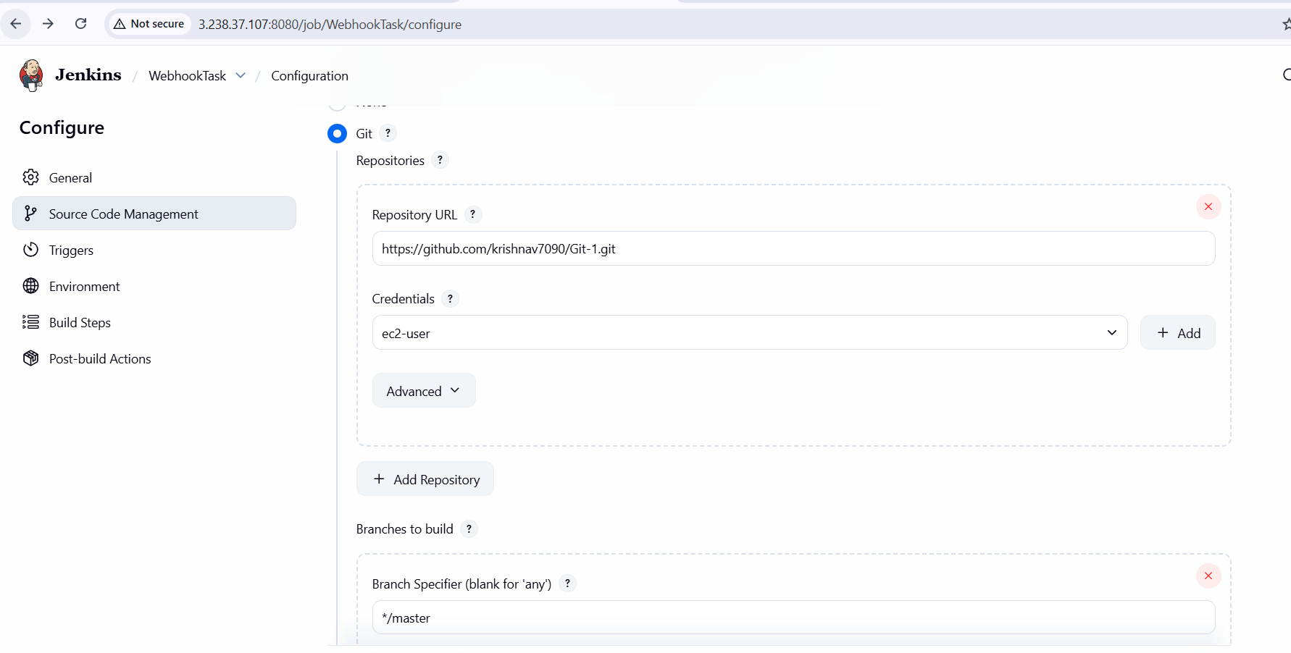
- Enable GitHub Webhook Trigger in Jenkins
- Go to Build Triggers
- Check GitHub hook trigger for GITScm polling
- Click Save
- Copy Jenkins Webhook URL
- Jenkins webhook URL format:
http://<JENKINS_PUBLIC_IP>:8080/github-webhook/
- Example:
http://3.238.37.107:8080/github-webhook/
- Configure Webhook in GitHub Repository
- Open GitHub repository
- Go to Settings → Webhooks
- Click Add webhook
- Enter Payload URL (Jenkins webhook URL)
- Content type: application/json
- Secret: (leave empty)
- Select Just the push event or Send me everything
- Enable Active
- Click Add webhook
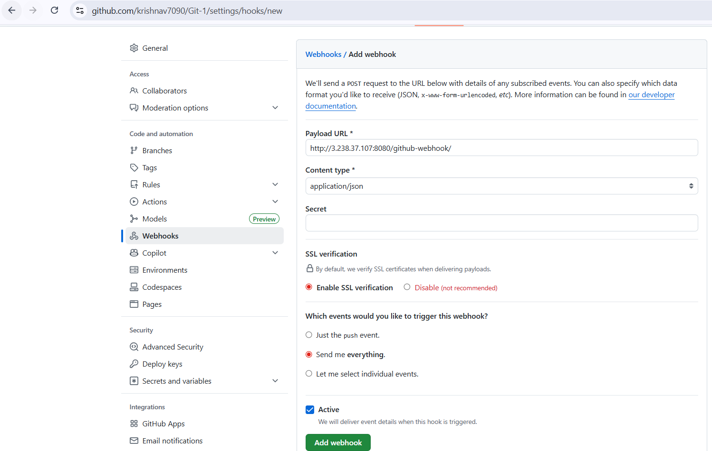
- Verify Webhook Configuration
- GitHub shows message: webhook created successfully
- Webhook delivery status should be successful
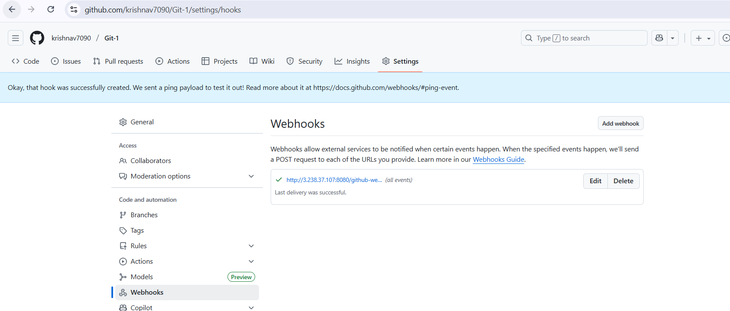
- Trigger Build Using GitHub Push
- Modify any file in GitHub repository (example: README.md)
- Commit and push changes
- Jenkins job should automatically trigger
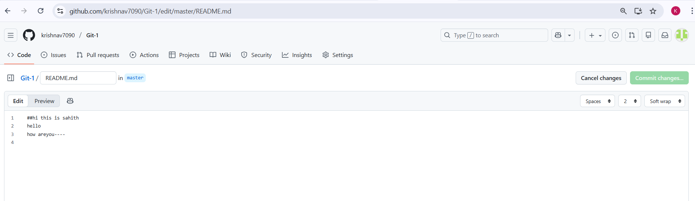
- Verify Jenkins Build
- Open Jenkins job → Build History
- Check latest build triggered by GitHub
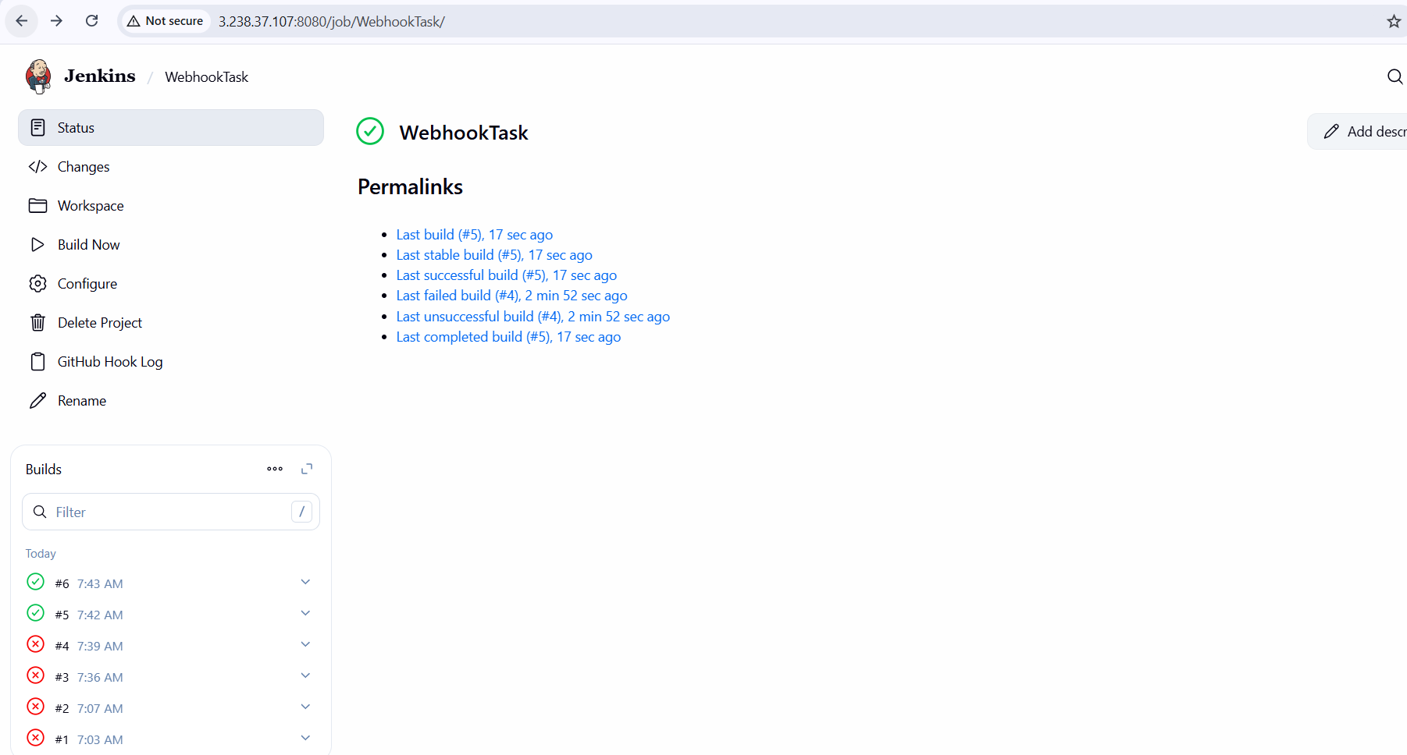
- Open Console Output
- Confirm message:
“Started by GitHub push”
- Build status should be SUCCESS
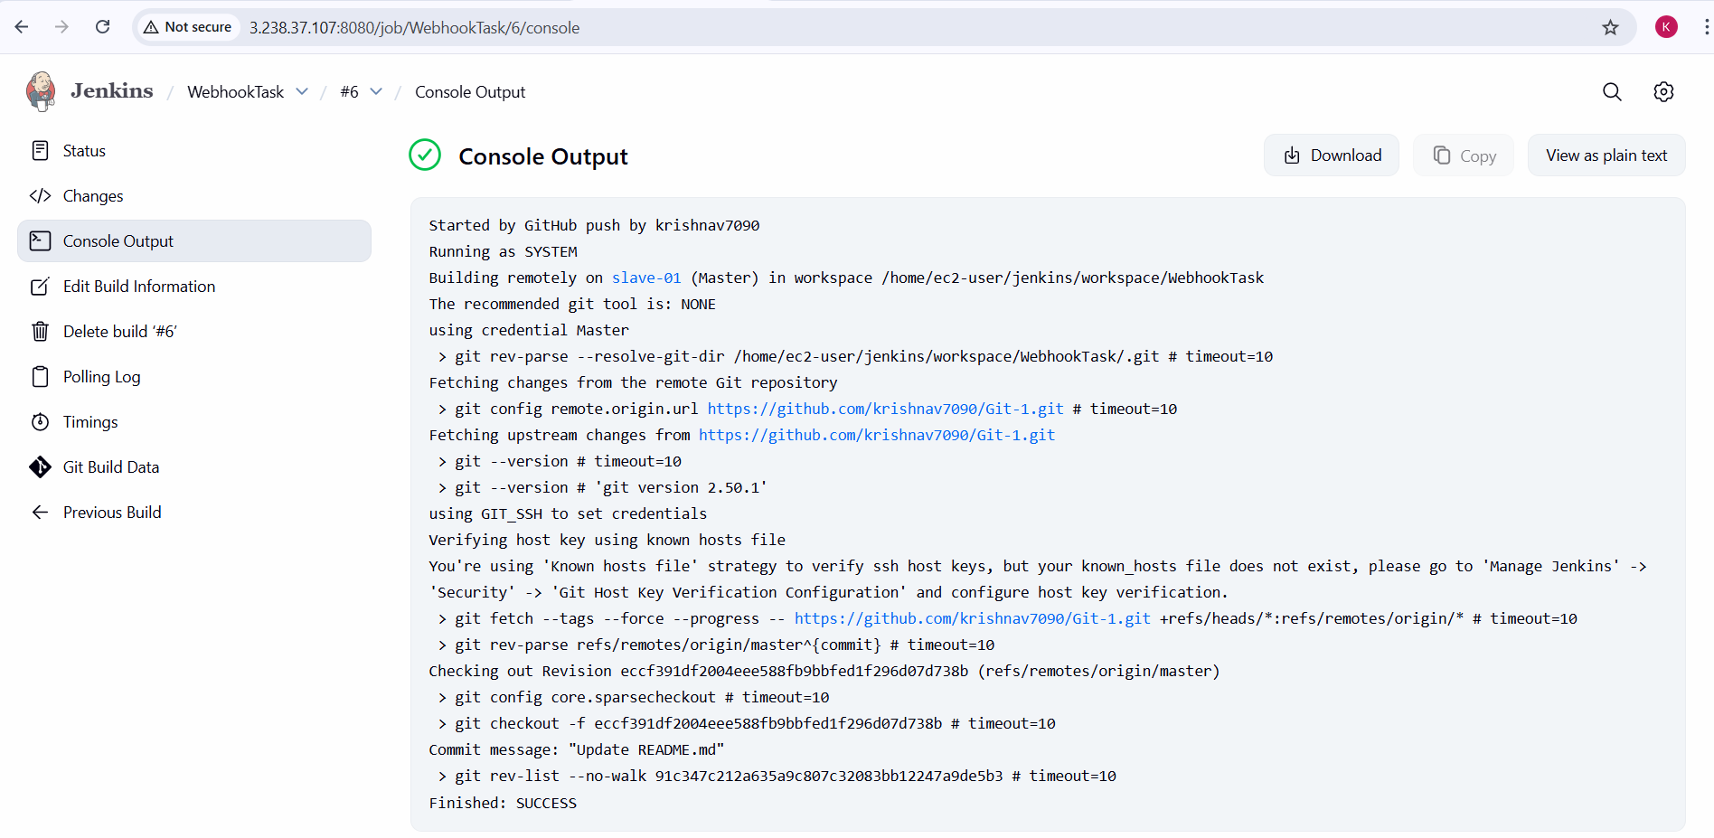
Result
Jenkins job is successfully integrated with GitHub using webhooks. Any code push to the repository automatically triggers the Jenkins build without manual intervention.
Conclusion:
GitHub webhooks were successfully configured with Jenkins, enabling continuous integration. This setup ensures real-time build automation whenever changes are pushed to the repository, improving development efficiency and reducing manual effort.

Task Title
Configure Poll SCM and Build Periodically Options in Jenkins Job
Objective
To automate Jenkins job execution by configuring Poll SCM for source code–based triggers and Build Periodically for time-based scheduled builds, ensuring continuous integration and regular job execution.
Prerequisites
- Jenkins installed and running
- Jenkins job created as a Freestyle project
- Git plugin installed in Jenkins
- GitHub repository available and accessible
- Valid GitHub credentials configured in Jenkins
- Network connectivity between Jenkins server and GitHub
Step-by-Step Implementation with Evidence
Poll SCM Configuration
- Created a Jenkins Freestyle job named pcmTask
- Configured Git under Source Code Management
- Added GitHub repository URL
- Selected valid credentials
- Configured branch as */master
- Enabled Poll SCM under Triggers
- Added cron schedule * * * * * (poll every minute)
- Saved the job
- Made changes in GitHub repository (README.md)
- Committed changes to GitHub
- Jenkins automatically detected SCM changes
- Job triggered and completed successfully (verified via Console Output)
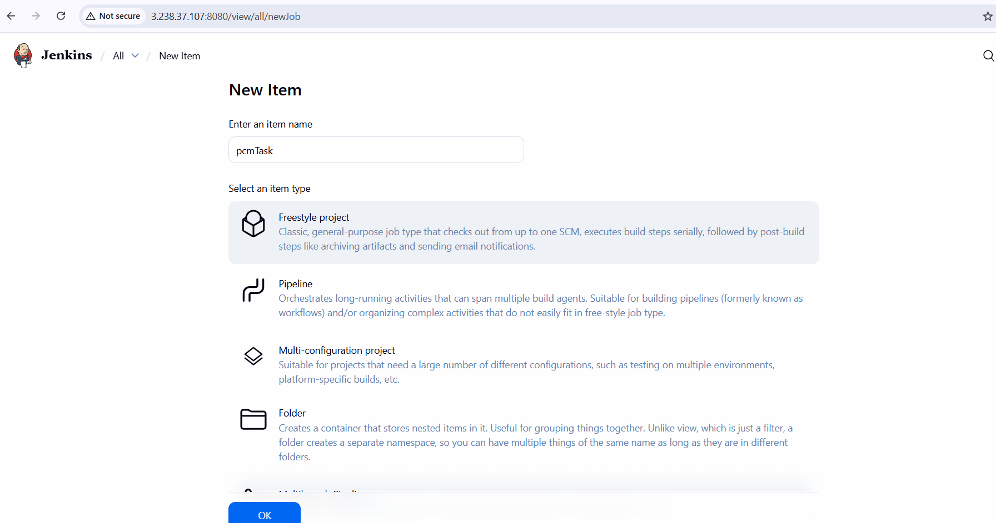
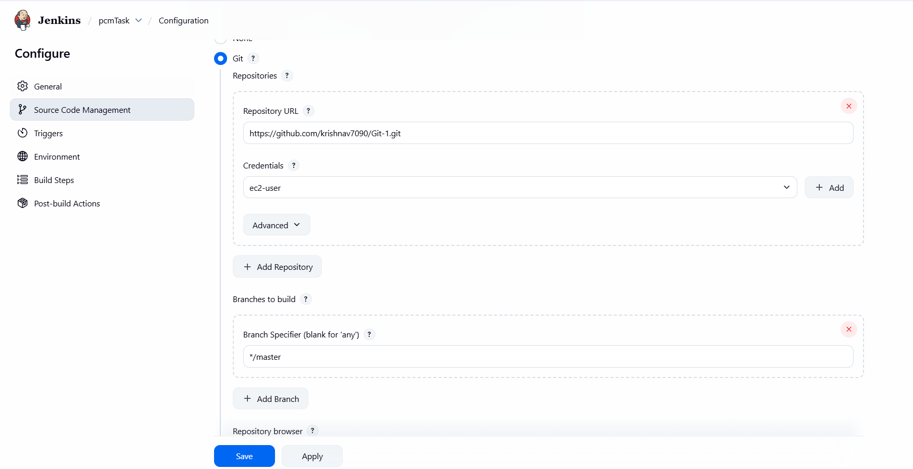
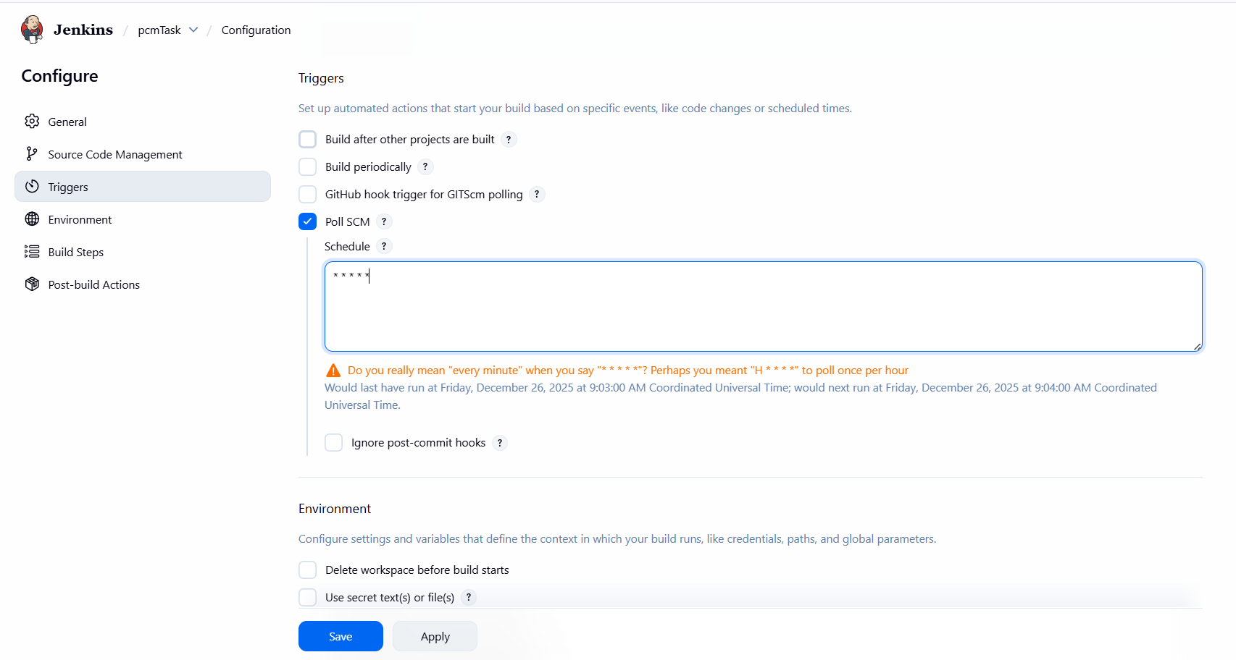
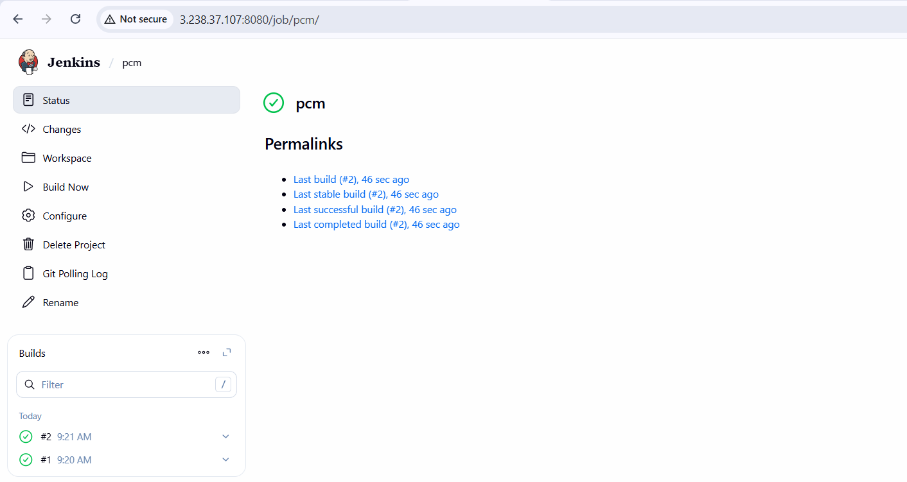
- Job triggered and completed successfully (verified via Console Output)
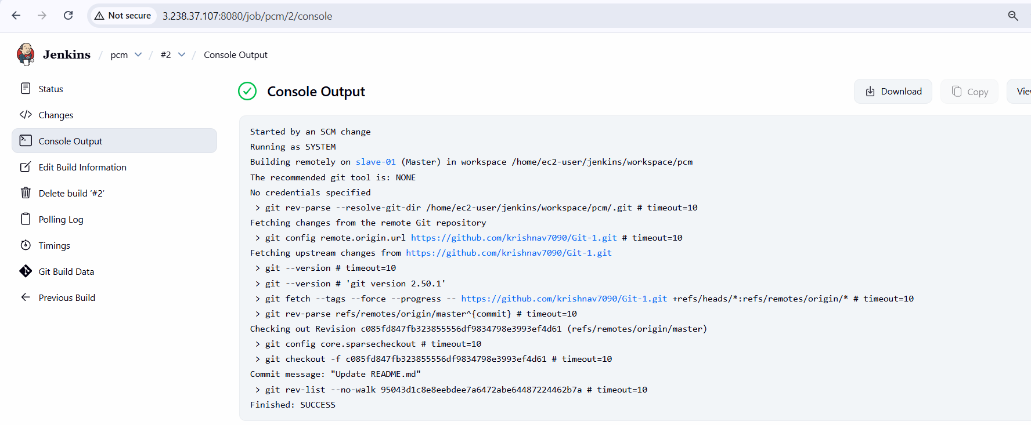
Build Periodically Configuration
- Created another Jenkins Freestyle job named periodical task
- Configured GitHub repository under Source Code Management
- Set branch as */master
- Enabled Build periodically under Triggers
- Added cron schedule * * * * * (runs every minute)
- Saved the job
- Jenkins triggered builds automatically based on the schedule
- Multiple successful builds observed in Build History
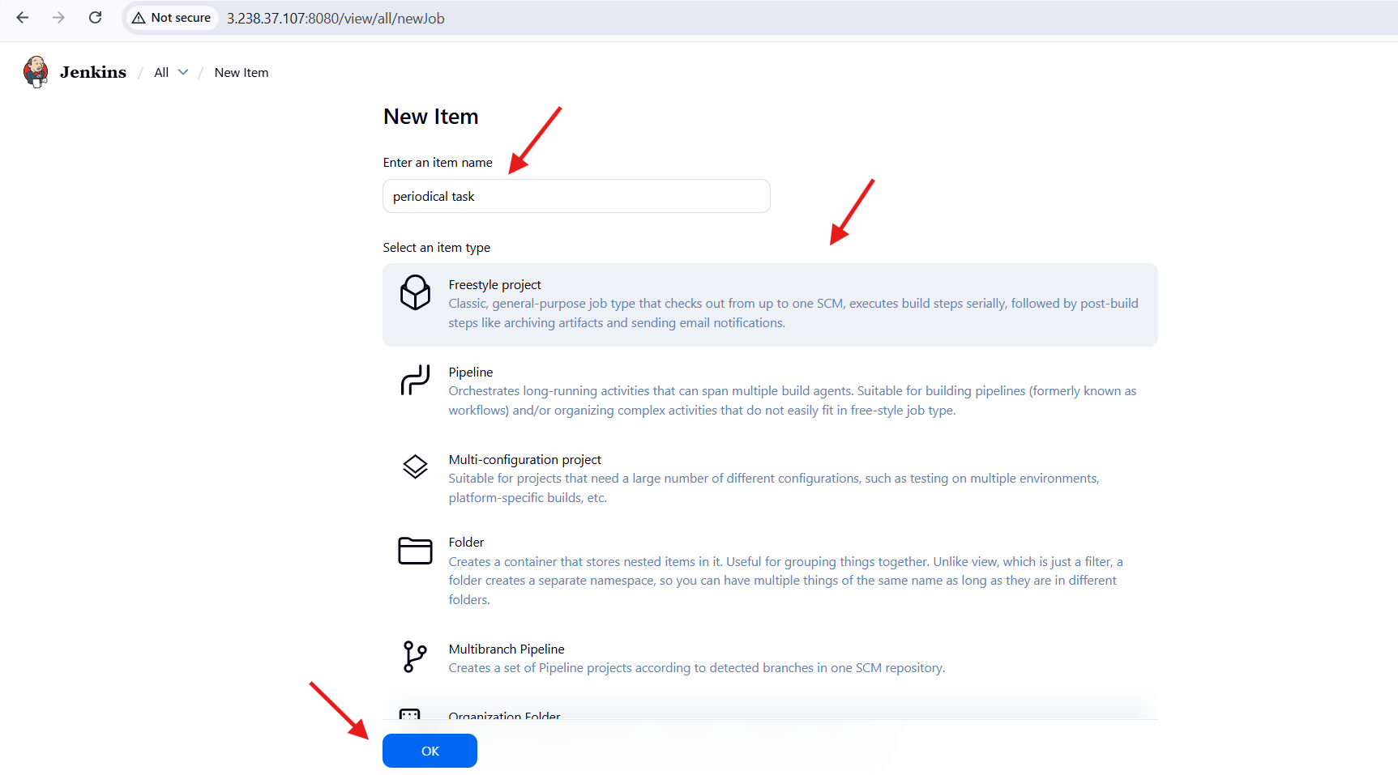
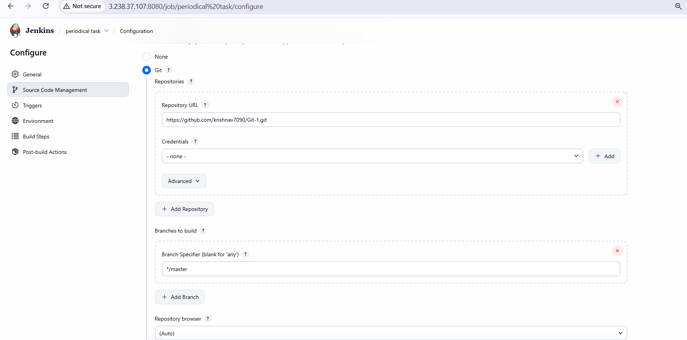
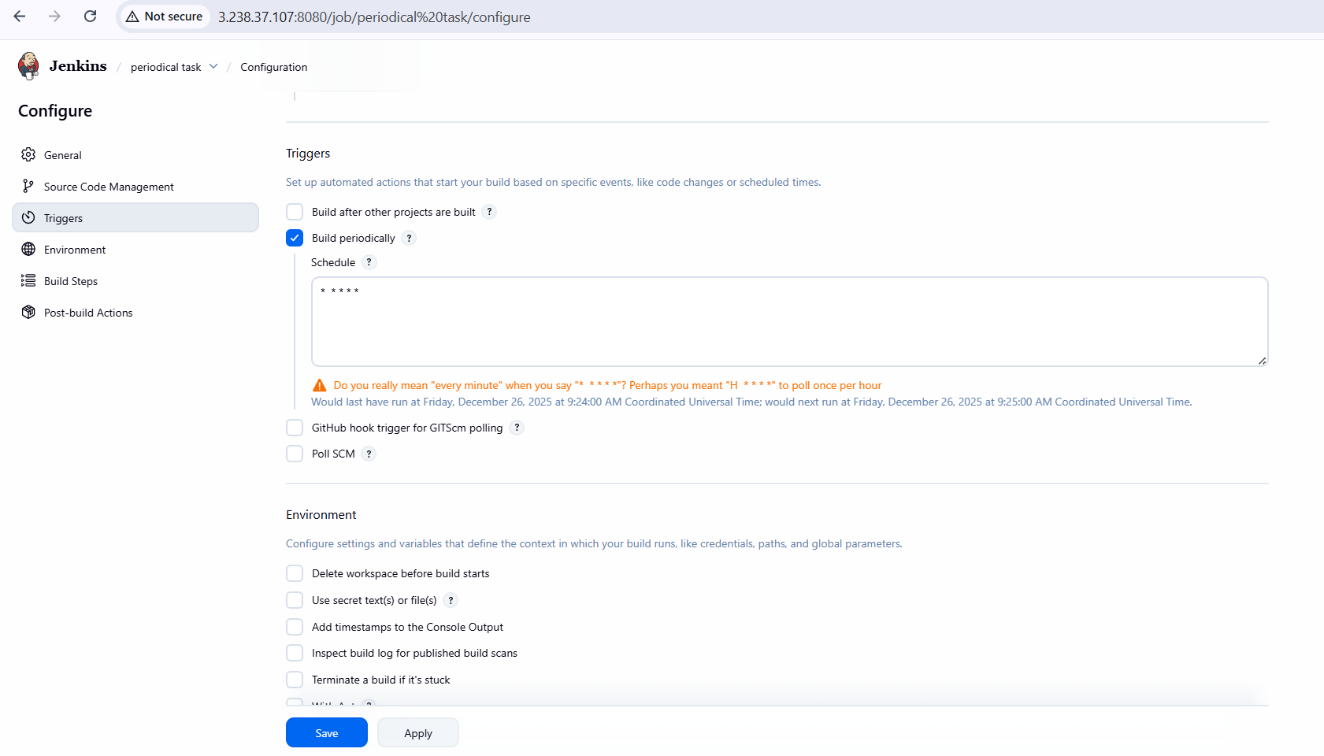
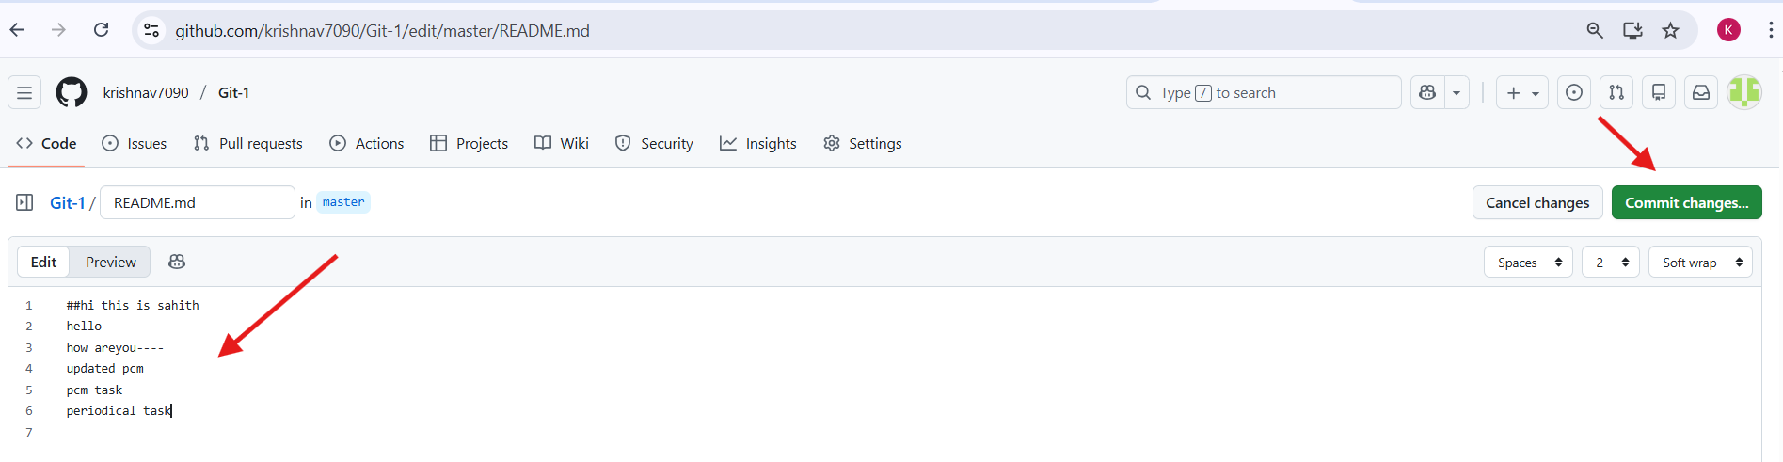
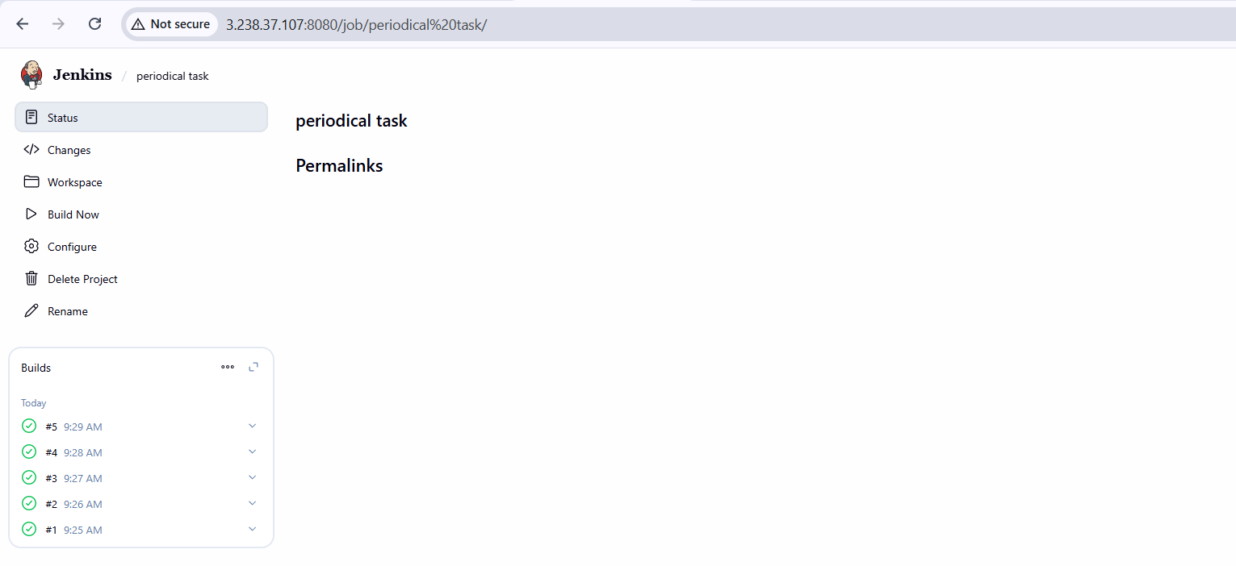
- Job triggered and completed successfully (verified via Console Output)
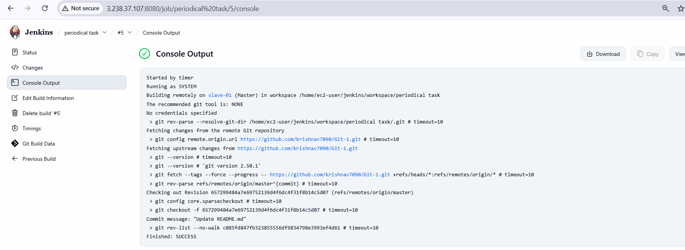
Validation Steps
- Verified build triggers occurred automatically
- Checked Console Output for successful execution
- Confirmed SCM-triggered build ran only after GitHub commit
- Confirmed periodic job ran continuously at scheduled intervals
- Ensured build status showed SUCCESS
Issues Faced
- Jenkins warning appeared for frequent cron execution (* * * * *)
- Warning acknowledged as expected behaviour for demonstration/testing
Conclusion:
Poll SCM and Build Periodically triggers were successfully configured in Jenkins. Poll SCM ensured builds were triggered only on source code changes, while Build Periodically enabled time-based automation. Both approaches improved automation and continuous integration efficiency, and the jobs executed reliably without failures.

Task Title
Take backup of Jenkins server by using bash script.
Objective
To create and execute a shell script that performs a complete backup of Jenkins configuration and data, ensuring recovery readiness by securely archiving jobs, plugins, users, secrets, nodes, and workspace files.
Prerequisites
- EC2 instance running Amazon Linux 2023
- Jenkins installed and running on the instance
- Root or sudo access to the server
- Jenkins home directory available at /var/lib/jenkins
- Basic knowledge of Linux shell scripting
Step-by-Step Implementation with Evidence
- Logged into the EC2 instance via SSH
- Switched to root user using sudo -i
- Created a backup script named jenkins-buckup.sh
- Edited the script using vi and added backup logic
- Configured script to back up:
  - Jenkins core XML configuration files
  - Plugins and pinned plugins
  - Jobs (including folder-based jobs)
  - Users and credentials data
  - Secrets directory
  - Jenkins nodes configuration
  - Workspace data
- Implemented recursive backup for nested Jenkins jobs
- Generated timestamp-based archive names for uniqueness
- Created a compressed backup archive (.tar.gz)
- Stored the backup archive in /root
- Cleaned up temporary files after backup completion
- Executed the script successfully with exit code 0
Script:
#!/bin/bash -xe
set -o pipefaildate=$(date +"%d%m%y%H%M")
readonly JENKINS_HOME="/var/lib/jenkins"
readonly DEST_FILE="/root"
readonly CUR_DIR=$(cd "$(dirname "${BASH_SOURCE:-$0}")" && pwd)
readonly TMP_DIR="${CUR_DIR}/tmp"
readonly ARC_NAME="jenkins-backup"
readonly ARC_DIR="${TMP_DIR}/${ARC_NAME}"
readonly TMP_TAR_NAME="${TMP_DIR}/${date}.tar.gz"backup_jobs() {
local run_in_path="$1"
local rel_depth=${run_in_path#${JENKINS_HOME}/jobs}
rel_depth=${rel_depth#/} [ -d "${run_in_path}" ] || return 0 cd "${run_in_path}" find . -maxdepth 1 -type d | while read -r job_name; do
[ "${job_name}" = "." ] && continue
[ "${job_name}" = ".." ] && continue mkdir -p "${ARC_DIR}/jobs/${rel_depth}/${job_name}" find "${run_in_path}/${job_name}" -maxdepth 1 \( -name "*.xml" -o -name "nextBuildNumber" \) -print0 \
| xargs -0 -r -I {} cp {} "${ARC_DIR}/jobs/${rel_depth}/${job_name}/" if [ -f "${run_in_path}/${job_name}/config.xml" ] &&
grep -q "com.cloudbees.hudson.plugins.folder.Folder" "${run_in_path}/${job_name}/config.xml"; then
backup_jobs "${run_in_path}/${job_name}/jobs"
fi
done cd "${OLDPWD:-/}" || true
}cleanup() {
rm -rf "${ARC_DIR}"
}main() {
rm -rf "${ARC_DIR}" "${TMP_TAR_NAME}" for dir in plugins jobs users secrets nodes workspace; do
mkdir -p "${ARC_DIR}/${dir}"
done cp "${JENKINS_HOME}/"*.xml "${ARC_DIR}" 2>/dev/null || true
cp "${JENKINS_HOME}/plugins/"*.[hj]pi "${ARC_DIR}/plugins" 2>/dev/null || true
cp "${JENKINS_HOME}/plugins/"*.[hj]pi.pinned "${ARC_DIR}/plugins" 2>/dev/null || true [ -d "${JENKINS_HOME}/users" ] && cp -R "${JENKINS_HOME}/users/"* "${ARC_DIR}/users" 2>/dev/null || true
[ -d "${JENKINS_HOME}/secrets" ] && cp -R "${JENKINS_HOME}/secrets/"* "${ARC_DIR}/secrets" 2>/dev/null || true
[ -d "${JENKINS_HOME}/nodes" ] && cp -R "${JENKINS_HOME}/nodes/"* "${ARC_DIR}/nodes" 2>/dev/null || true
[ -d "${JENKINS_HOME}/workspace" ] && cp -R "${JENKINS_HOME}/workspace/"* "${ARC_DIR}/workspace" 2>/dev/null || true [ -d "${JENKINS_HOME}/jobs" ] && backup_jobs "${JENKINS_HOME}/jobs" cd "${TMP_DIR}"
tar -czvf "${TMP_TAR_NAME}" "${ARC_NAME}"
cd "${OLDPWD:-/}" || true mv -f "${TMP_TAR_NAME}" "${DEST_FILE}"
cleanup
exit 0
}main

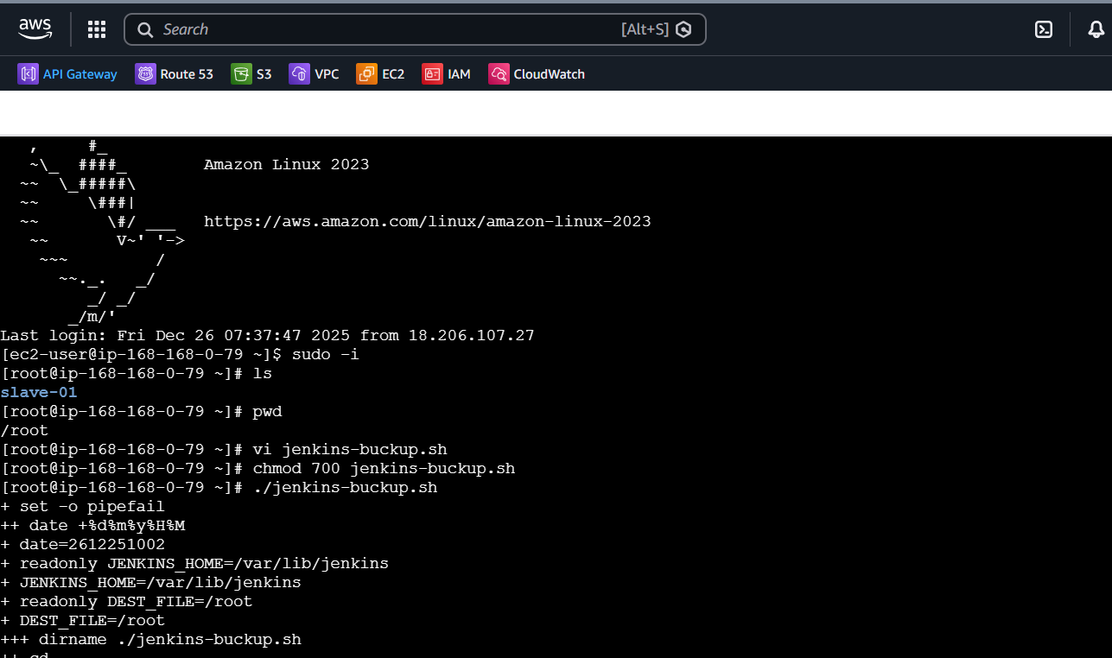
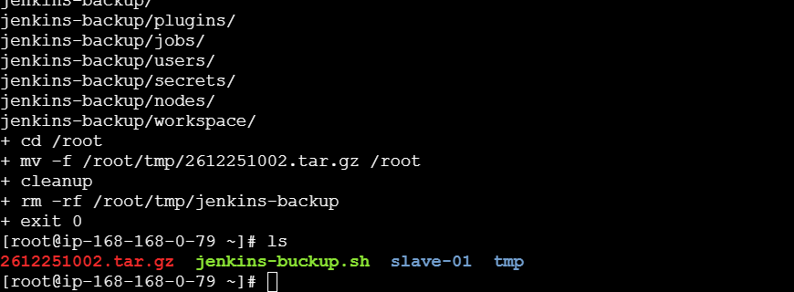
Validation Steps:
- Verified script execution completed without errors
- Confirmed creation of timestamped.tar.gz file in /root
- Checked that Jenkins configuration directories were included in the archive
- Ensured temporary directories were removed after execution
Conclusion:
The Jenkins backup script was successfully created and executed, generating a complete and structured backup of Jenkins data. This approach ensures reliable disaster recovery and provides a reusable solution for periodic Jenkins backups in production environments.

Task Title
Take Jenkins Backup Using Thin Backup Plugin
Objective
To configure and use the ThinBackup plugin in Jenkins to take a reliable backup of global and job-specific configuration data for disaster recovery and system restoration.
Prerequisites
- Jenkins installed and running
- Administrative access to Jenkins
- Internet connectivity to install Jenkins plugins
- Sufficient disk space for backup storage
- Access to Jenkins Manage Jenkins section
Step-by-Step Implementation with Evidence
- Opened Jenkins Dashboard
- Navigated to Manage Jenkins → Plugins
- Selected Available plugins
- Searched for ThinBackup
- Installed the ThinBackup plugin
- Verified successful plugin installation
- Navigated to Manage Jenkins → System
- Located ThinBackup Configuration
- Configured backup directory as /var/lib/jenkins/thinbackup
- Left backup schedules empty for manual execution
- Set maximum number of backup sets to -1
- Saved the configuration
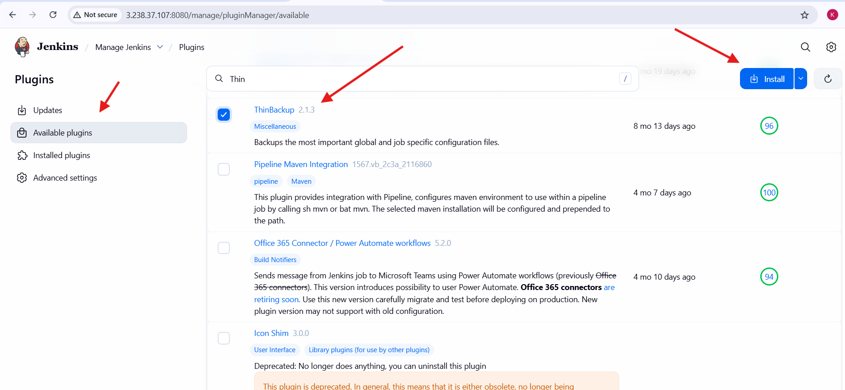
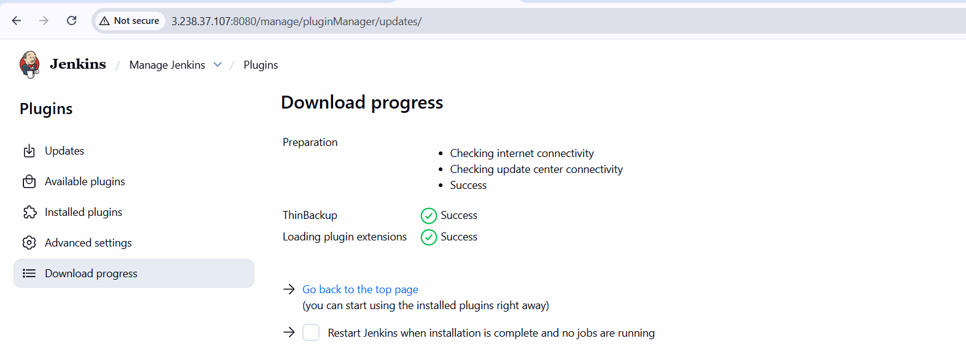
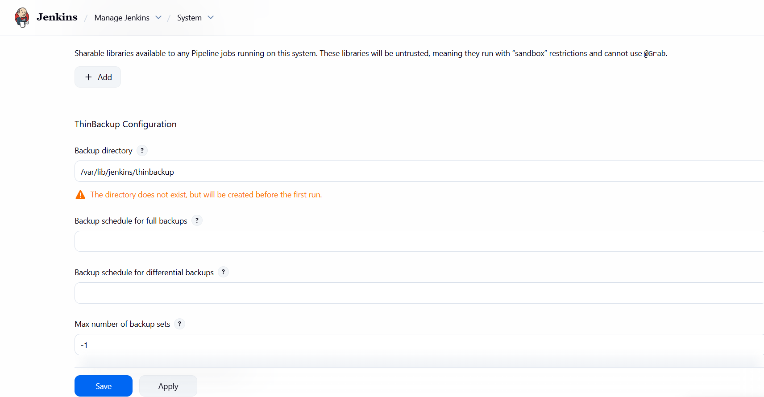
- Navigated to Manage Jenkins → ThinBackup
- Clicked Backup now to initiate backup
- Backup completed successfully
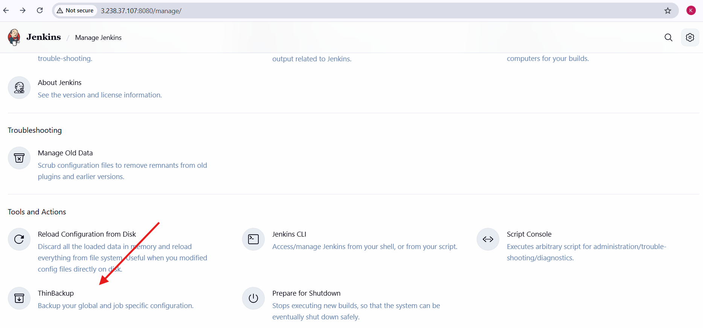
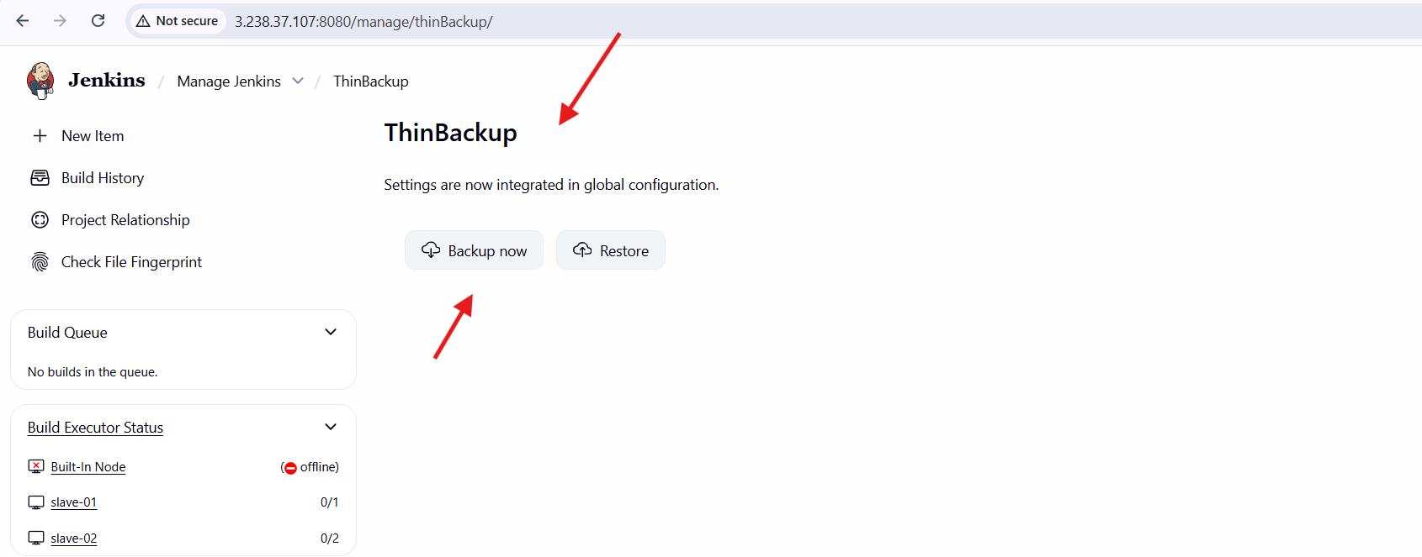
Validation Steps
- Verified Thin Backup plugin appears under installed plugins
- Confirmed backup directory creation in Jenkins home
- Checked Thin Backup page for successful backup execution
- Ensured no errors were displayed during backup process
Conclusion
The Thin Backup plugin was successfully installed and configured in Jenkins. A complete backup of Jenkins global and job-specific configuration data was taken manually, ensuring system recovery capability and safeguarding Jenkins configuration.

Task Title
Setup a New Jenkins Server and Restore Backup from Existing Jenkins Server taken task 4
Objective
To set up a new Jenkins server and restore Jenkins configuration and data by transferring and dumping a previously taken back up from an existing Jenkins server, ensuring continuity and disaster recovery readiness.
Prerequisites
- New EC2 instance launched with Amazon Linux 2023
- Jenkins installed and running on the new server
- SSH access to both source and destination EC2 instances
- Jenkins backup archive available from Task 4
- Valid .pem key with correct permissions
- Root or sudo access on both servers
Step-by-Step Implementation with Evidence
Source Jenkins Server
- Logged into the existing Jenkins EC2 instance
- Switched to root user using sudo -i
- Executed Jenkins backup script
- Generated a timestamped backup archive (.tar.gz)
- Verified backup file presence in /root
- Updated private key permissions to 600
- Transferred backup archive to the new Jenkins server using scp

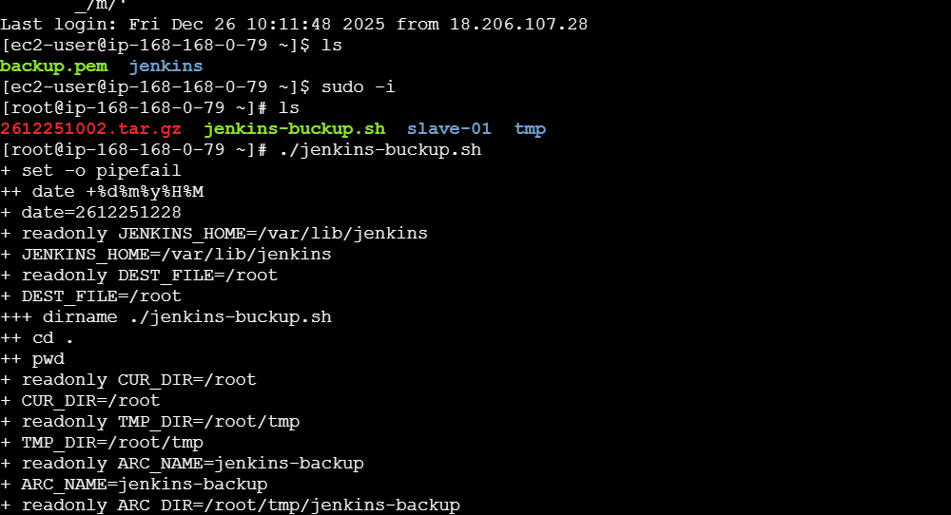
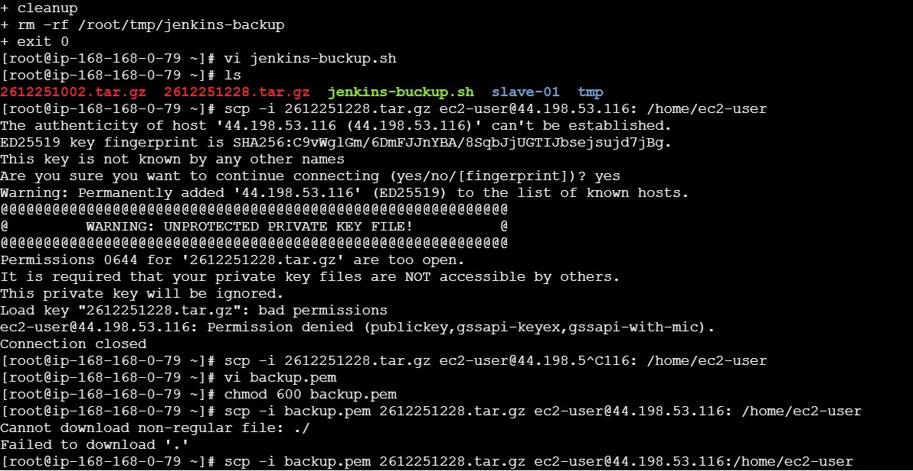
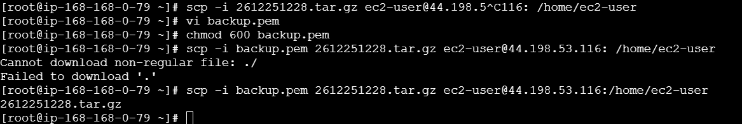
Destination Jenkins Server
- Logged into the new Jenkins EC2 instance
- Verified Jenkins service status and confirmed it was running
- Switched to root user
- Moved the backup archive to /var/lib/jenkins
- Prepared Jenkins home directory for restoring data from the backup
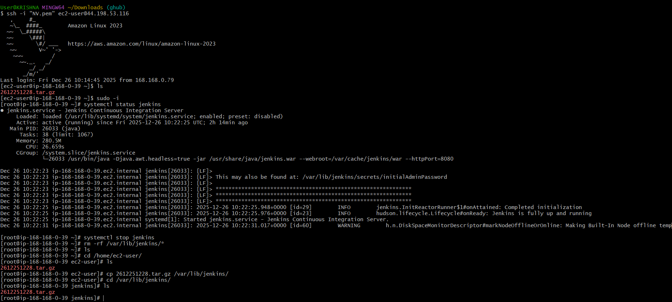
Validation Steps:
- Verified backup archive transfer completed successfully
- Confirmed Jenkins service was active on the new server
- Checked presence of backup archive in Jenkins home directory
- Ensured no file transfer or permission errors occurred
Error Faced:
- Encountered SCP permission error due to incorrect private key permissions
- Resolved by setting key file permissions to chmod 600
Conclusion:
A new Jenkins server was successfully set up and the backup from the existing Jenkins server was transferred and placed into the Jenkins home directory. This ensures Jenkins configuration and job data can be restored, supporting system migration and disaster recovery requirements.

Overall Tasks Validation Steps
- Verified Jenkins master successfully connected with two slave nodes
- Confirmed jobs executed only on assigned slave nodes using labels
- Verified GitHub webhook triggered Jenkins jobs on code commits
- Confirmed Poll SCM triggered jobs only after SCM changes
- Verified Build Periodically triggered jobs based on cron schedule
- Validated Jenkins backup creation using custom bash script
- Verified backup creation using ThinBackup plugin
- Successfully transferred backup archive to a new Jenkins server
- Verified Jenkins service running on the new server after dumping backup
- Ensured no job, configuration, or plugin errors were observed

Overall Tasks Conclusion:
The Jenkins environment was successfully configured with multiple slave nodes, automated build triggers, and robust backup mechanisms. Both script-based and plugin-based backups were implemented and validated. A new Jenkins server was set up and restored using the existing backup, ensuring full disaster recovery capability and demonstrating a production-ready Jenkins CI/CD architecture.

